Comparative Analysis of Emergency Response Time in Conveyor Belt Motor Control Using Bare-Metal Embedded System and FreeRTOS

Real Time Operating Systems 25ES611
PROJECT REPORT

Submitted by

BL.EN. P2EBS25013 PAYAKATTU LAHARI

Submitted to

Dr. Surekha P


EMBEDDED SYSTEMS

AMRITA SCHOOL OF ENGINEERING, BENGALPRU
AMRITA VISHWA VIDYAPEETHAM
Bengaluru 560035

Table of Contents
Abstract ……………………………………………………………………………………..3

CHAPTER 1: INTRODUCTION 4
1.1 Problem Statement 5
1.2 Objective 5
CHAPTER 2: LITERATURE SURVEY 6
Research gap…………………………………………………………………………………..9
CHAPTER 3: METHODOLOGY 10
3.1 Block Diagram 10
3.2 Hardware implementation 11
3.3 Software Implementation 13
3.4 FreeRTOS Task Architecture 16
CHAPTER 4: RESULT AND DISCUSSION 19
1:Rate Monotonic Scheduling 19
2: Deadline Monotonic Scheduling 20
3: Earliest Deadline First (EDF), 21
CONCLUSION 24
REFERENCES 25

ABSTRACT:

Real-Time Operating Systems (RTOS) play an important role in embedded systems where tasks must be completed within specified timing constraints. This project presents the implementation and comparative analysis of Non-RTOS execution and three scheduling algorithms: Rate Monotonic Scheduling (RMS), Deadline Monotonic Scheduling (DMS), and Earliest Deadline First (EDF) using the ESP32 microcontroller. The developed system controls motor operations through Forward, Reverse, and Emergency tasks. Task execution behavior was monitored and analyzed using Serial Studio by measuring execution time, response time, latency, and task priority. Experimental results demonstrate that RTOS-based scheduling improves responsiveness and task management compared with conventional sequential execution. Among all implemented methods, EDF achieved better scheduling efficiency due to dynamic priority allocation.

Keywords: RTOS, ESP32, RMS, DMS, EDF, Serial Studio, Scheduling Algorithms

CHAPTER 1 — INTRODUCTION

Real-Time Operating Systems (RTOS) have become an essential component in modern embedded systems where predictable execution and strict timing requirements are necessary. Unlike conventional execution methods, RTOS enables deterministic task scheduling and resource management to ensure that critical operations are completed within specified deadlines. Real-time scheduling plays a significant role in applications such as industrial automation, automotive control systems, robotics, Internet of Things (IoT), healthcare devices, and safety-critical embedded platforms.

With increasing complexity in embedded applications, sequential execution methods are often unable to satisfy timing constraints when multiple tasks compete for processor resources. Therefore, efficient scheduling techniques are required to improve response time, reduce execution delay, and guarantee system stability under concurrent workloads. Traditional fixed scheduling methods provide predictable execution but may suffer from poor adaptability during runtime variations. Dynamic scheduling approaches improve flexibility and optimize processor utilization under changing execution conditions.

Among scheduling approaches, Rate Monotonic Scheduling (RMS), Deadline Monotonic Scheduling (DMS), and Earliest Deadline First (EDF) are widely adopted in real-time systems. RMS assigns static priorities based on task periodicity, where shorter periods receive higher priority. DMS extends fixed-priority scheduling by assigning priorities according to deadline constraints. EDF dynamically adjusts priorities and executes tasks with the nearest deadline first, resulting in improved responsiveness and efficient deadline management.

In this work, a comparative implementation of Non-RTOS execution and RTOS-based scheduling algorithms is carried out using the ESP32 microcontroller platform. Motor control operations consisting of Forward, Reverse, and Emergency tasks are implemented under different scheduling mechanisms. System behavior is evaluated using execution time, response time, latency, and scheduling performance metrics obtained through Serial Studio visualization. The proposed implementation provides practical understanding of scheduling behavior and demonstrates the impact of scheduling algorithms on embedded real-time performance.

The main contribution of this work is the practical implementation and comparative analysis of Non-RTOS execution, RMS, DMS, and EDF scheduling techniques using hardware-based validation and real-time timing analysis.

1.1 PROBLEM STATEMENT:

Modern embedded systems frequently execute multiple tasks simultaneously and require deterministic behavior under strict timing constraints. Conventional sequential execution techniques process tasks one after another and do not provide efficient handling of concurrent operations. As a result, critical events such as emergency requests may experience delayed execution and increased response time.
Although Real-Time Operating Systems (RTOS) provide scheduling mechanisms to improve responsiveness and timing predictability, selecting an appropriate scheduling algorithm remains a challenge because different algorithms exhibit different execution characteristics under varying workloads. Existing approaches mainly focus on simulation-based evaluation and provide limited hardware-level comparative analysis.
Therefore, there is a need to implement and analyze multiple scheduling techniques under practical conditions to evaluate their impact on execution time, response time, latency, and deadline behavior. This work addresses this challenge through implementation and comparison of Non-RTOS execution, Rate Monotonic Scheduling (RMS), Deadline Monotonic Scheduling (DMS), and Earliest Deadline First (EDF) using ESP32 and real-time visualization through Serial Studio.

1.2 OBJECTIVES:
The primary objective of this work is to design and evaluate real-time scheduling algorithms for embedded task execution using ESP32 and FreeRTOS.
The specific objectives are as follows:
- To implement sequential task execution using a Non-RTOS approach.
- To implement Rate Monotonic Scheduling (RMS) for fixed-priority task management.
- To implement Deadline Monotonic Scheduling (DMS) for deadline-oriented scheduling.
- To implement Earliest Deadline First (EDF) for dynamic priority scheduling.
- To measure execution time, response time, latency, and scheduling behavior.
- To visualize task execution and timing performance using Serial Studio.
- To compare the performance of Non-RTOS, RMS, DMS, and EDF scheduling techniques based on experimental results.
- To identify the scheduling approach that provides better responsiveness and deadline satisfaction for real-time embedded applications.

CHAPTER 2 — LITERATURE SURVEY

Real-time embedded systems require efficient scheduling mechanisms to guarantee deterministic execution and deadline satisfaction. Several researchers have proposed scheduling approaches to improve execution performance, reduce response delay, and optimize resource utilization.

[1] Traditional embedded scheduling approaches often suffer from limited flexibility and reduced responsiveness under varying workloads. Zhang and Li proposed a real-time embedded architecture using STM32 integrated with FreeRTOS and advanced scheduling techniques. Their work implemented Rate Monotonic Scheduling (RMS) and Deadline Monotonic Scheduling (DMS) to improve task completion efficiency and reduce execution overhead. Experimental analysis demonstrated nearly complete deadline satisfaction and improved response performance under different operating conditions. The proposed approach proved suitable for industrial automation and IoT-based embedded applications.

[2] Conventional static scheduling techniques assume fixed execution conditions and therefore struggle to adapt to runtime workload variations. To overcome this limitation, Benmachiche et al. introduced adaptive real-time scheduling techniques capable of modifying scheduling decisions dynamically during execution. Their approach integrated feedback mechanisms and adaptive resource allocation methods to improve responsiveness and maintain timing guarantees under uncertain operating environments. Experimental observations showed enhanced flexibility and improved runtime adaptability.

[3] Existing industrial scheduling methods experience difficulty handling simultaneous real-time production tasks and dynamic user interactions. Kwon et al. proposed a deterministic scheduling and resource planning framework for Industrial IoT-based manufacturing systems. Their methodology optimized processor allocation, memory utilization, and task execution planning while maintaining strict deadline constraints. Results demonstrated improved responsiveness and complete deadline compliance in industrial environments.

[4] Conventional Earliest Deadline First scheduling provides efficient deadline management but often ignores energy optimization requirements. To address this limitation, Gharbi et al. developed an energy-aware scheduling framework integrating Earliest Deadline First (EDF) with Dynamic Voltage and Frequency Scaling (DVFS). Their scheduling strategy reduced execution overhead and minimized deadline misses while lowering energy consumption. Experimental results indicated improved scheduling efficiency and balanced processor utilization.

[5] Traditional multi-thread scheduling approaches generally encounter limitations related to processor efficiency and dynamic task prioritization. Reddy et al. proposed an augmented Particle Swarm Optimization-based scheduling framework to improve task execution and resource utilization. Their approach dynamically adjusted scheduling decisions based on execution requirements and system conditions. Results demonstrated improved deadline handling and enhanced computational efficiency for real-time embedded applications.

[6] Conventional fixed-priority scheduling methods often experience increased response time and reduced processor utilization when handling dynamic real-time workloads. Gurupriya et al. conducted a comparative study between Earliest Deadline First (EDF) and Rate Monotonic Scheduling (RMS) for real-time applications. Their work implemented both scheduling techniques using Arduino and simulation platforms to evaluate performance using execution time, CPU utilization, latency, and response time metrics. Experimental results showed that EDF achieved lower latency and better CPU utilization than RMS due to its dynamic priority allocation mechanism, demonstrating improved scheduling flexibility for time-critical systems.

[7] Traditional automotive control systems commonly employ fixed scheduling mechanisms because of their deterministic nature; however, such approaches become inefficient under mixed-criticality workloads and changing runtime conditions. Pradeep Kumar and Pillai proposed a dynamic scheduling framework for automotive safety-critical applications operating under AUTOSAR architecture. Their work compared static and dynamic scheduling techniques and demonstrated that dynamic scheduling improved flexibility, reduced response delay, and maintained timing guarantees while supporting efficient resource sharing among multiple Electronic Control Units (ECUs).

[8] Existing communication systems in automotive networks frequently encounter latency and congestion issues under heavy message traffic conditions. Niranjan et al. proposed a latency optimization framework for Controller Area Network (CAN)-based communication systems using scheduling and message prioritization mechanisms. Their approach analyzed message transmission delay and dynamically optimized scheduling priorities to minimize latency and improve communication reliability. Experimental observations demonstrated reduced collision rates and improved network efficiency in real-time automotive environments.

[9] Conventional industrial monitoring systems often suffer from inefficient task management and limited scalability when handling multiple sensor inputs simultaneously. Chandru et al. proposed an IoT-enabled predictive maintenance architecture integrating ESP32, FreeRTOS, CAN communication, and cloud analytics. Their system employed concurrent task execution under FreeRTOS to improve embedded processing efficiency while maintaining reliable sensor communication. Results demonstrated improved real-time monitoring and predictive maintenance capability suitable for industrial automation environments.

[10] Traditional Bare-Metal programming provides direct hardware control but becomes increasingly difficult to maintain and scale as system complexity increases. Wavale and Surekha conducted a comparative study between Bare-Metal and FreeRTOS implementation for real-time embedded applications. Their work evaluated execution efficiency, modularity, synchronization, and maintainability using practical implementation. Experimental analysis showed that Bare-Metal execution performs efficiently for simple applications, whereas FreeRTOS provides superior task management and concurrent execution capabilities for complex real-time systems.

[11] Conventional real-time embedded communication systems often experience increased transmission delay and reduced reliability when handling large-scale network traffic. To address this issue, Niranjan et al. proposed a latency analysis and scheduling optimization framework for Controller Area Network (CAN)-based communication systems. The proposed method introduced message timestamp analysis and priority-aware scheduling to reduce transmission delay and improve communication efficiency. Experimental results demonstrated reduced message collision, lower latency, and improved real-time communication performance for automotive applications.

[12] Traditional industrial monitoring approaches generally rely on periodic maintenance strategies, which may lead to increased downtime and reduced equipment utilization. Chandru et al. proposed an IoT-enabled predictive maintenance framework integrating ESP32, FreeRTOS, CAN communication, and cloud analytics. The proposed architecture enabled concurrent execution of sensing and communication tasks while maintaining deterministic timing behavior. Experimental observations demonstrated efficient sensor processing, improved predictive maintenance capability, and reliable real-time operation under industrial conditions.

[13] Conventional Bare-Metal programming approaches provide direct hardware control but become increasingly difficult to manage and maintain as application complexity increases. Wavale and Surekha proposed a comparative implementation between Bare-Metal execution and FreeRTOS scheduling for sensor–actuator systems. Their work introduced task-based execution and synchronization mechanisms under FreeRTOS while maintaining equivalent hardware functionality. Experimental analysis showed that Bare-Metal execution provided faster performance for simple systems, whereas FreeRTOS improved modularity, scalability, synchronization, and concurrent task management.

[14] Existing two-wheeler safety systems often suffer from delayed response and limited protection mechanisms during emergency conditions. Yashaswini et al. proposed a FreeRTOS-based real-time airbag deployment system using an ESP32 platform integrated with multiple sensors and interrupt-driven emergency handling. Their architecture employed task scheduling, semaphores, and synchronization techniques to ensure deterministic execution. Experimental evaluation demonstrated rapid deployment response with minimal context-switch latency, validating the effectiveness of RTOS for safety-critical embedded applications.

[15] Traditional embedded real-time systems generally prioritize execution performance but often neglect power optimization and energy efficiency. Ramegowda and Lin proposed an energy-aware scheduling framework for FreeRTOS platforms by integrating Dynamic Voltage and Frequency Scaling (DVFS) techniques with mixed task scheduling. Their approach extended conventional scheduling mechanisms to support periodic and aperiodic workloads while minimizing energy consumption. Experimental results demonstrated measurable energy savings while maintaining deadline satisfaction and execution performance under real-time constraints.

[16] Conventional real-time scheduling approaches generally provide deterministic execution but often fail to address power efficiency and dynamic workload handling simultaneously. Ramegowda and Lin proposed an energy-efficient scheduling framework for real-time embedded systems implemented using FreeRTOS. Their work extended Dynamic Voltage and Frequency Scaling (DVFS) techniques to support both periodic and aperiodic task execution while maintaining timing guarantees. The proposed Cycle Conserving Mixed Task (CCMT) algorithm dynamically adjusted processor frequency based on task demand and execution behavior. Experimental analysis demonstrated noticeable energy reduction without affecting throughput or violating task deadlines, highlighting the effectiveness of integrating power-aware scheduling with RTOS environments.

[17] Traditional scheduling algorithms such as Rate Monotonic (RM) and Earliest Deadline First (EDF) are effective for simple embedded applications; however, they encounter challenges in handling increasing computational complexity and security requirements in modern embedded platforms. Zhou proposed a comprehensive real-time scheduling framework integrated with deep learning concepts for complex embedded systems and network device security. The proposed model introduced adaptive scheduling decisions based on task classification and dynamic workload conditions while incorporating secure execution mechanisms. Experimental observations indicated improved scheduling flexibility, enhanced system reliability, and better execution performance for large-scale embedded applications operating under dynamic conditions.

Research Gap:

From the literature survey, it is observed that most existing studies focus on simulation-based scheduling evaluation, cloud-integrated embedded applications, industrial automation, automotive systems, communication optimization, and energy-aware scheduling techniques. Although several researchers have implemented RTOS scheduling methods such as RMS and EDF, limited work has focused on practical hardware-level comparative analysis of Non-RTOS execution, Rate Monotonic Scheduling (RMS), Deadline Monotonic Scheduling (DMS), and Earliest Deadline First (EDF) using ESP32 and real-time visualization tools.
Furthermore, most existing implementations rely on simulation environments or software-level evaluation without demonstrating actual timing behavior through execution metrics. Therefore, this work addresses this limitation by implementing multiple scheduling techniques on ESP32 hardware and evaluating their performance using execution time, response time, latency, task behavior, and Serial Studio-based timing visualization.

CHAPTER -3 METHODOLOGY

The proposed methodology implements and evaluates multiple scheduling approaches including Non-RTOS execution, Rate Monotonic Scheduling (RMS), Deadline Monotonic Scheduling (DMS), and Earliest Deadline First (EDF) using an ESP32 microcontroller platform. The developed system performs motor control operations through Forward, Reverse, and Emergency tasks while measuring timing behavior using Serial Studio. Execution time, response time, latency, and scheduling performance are analyzed under different scheduling conditions.
The implementation process consists of hardware interfacing, software scheduling implementation, task execution, and performance evaluation.

3.1 BLOCK DIAGRAM:
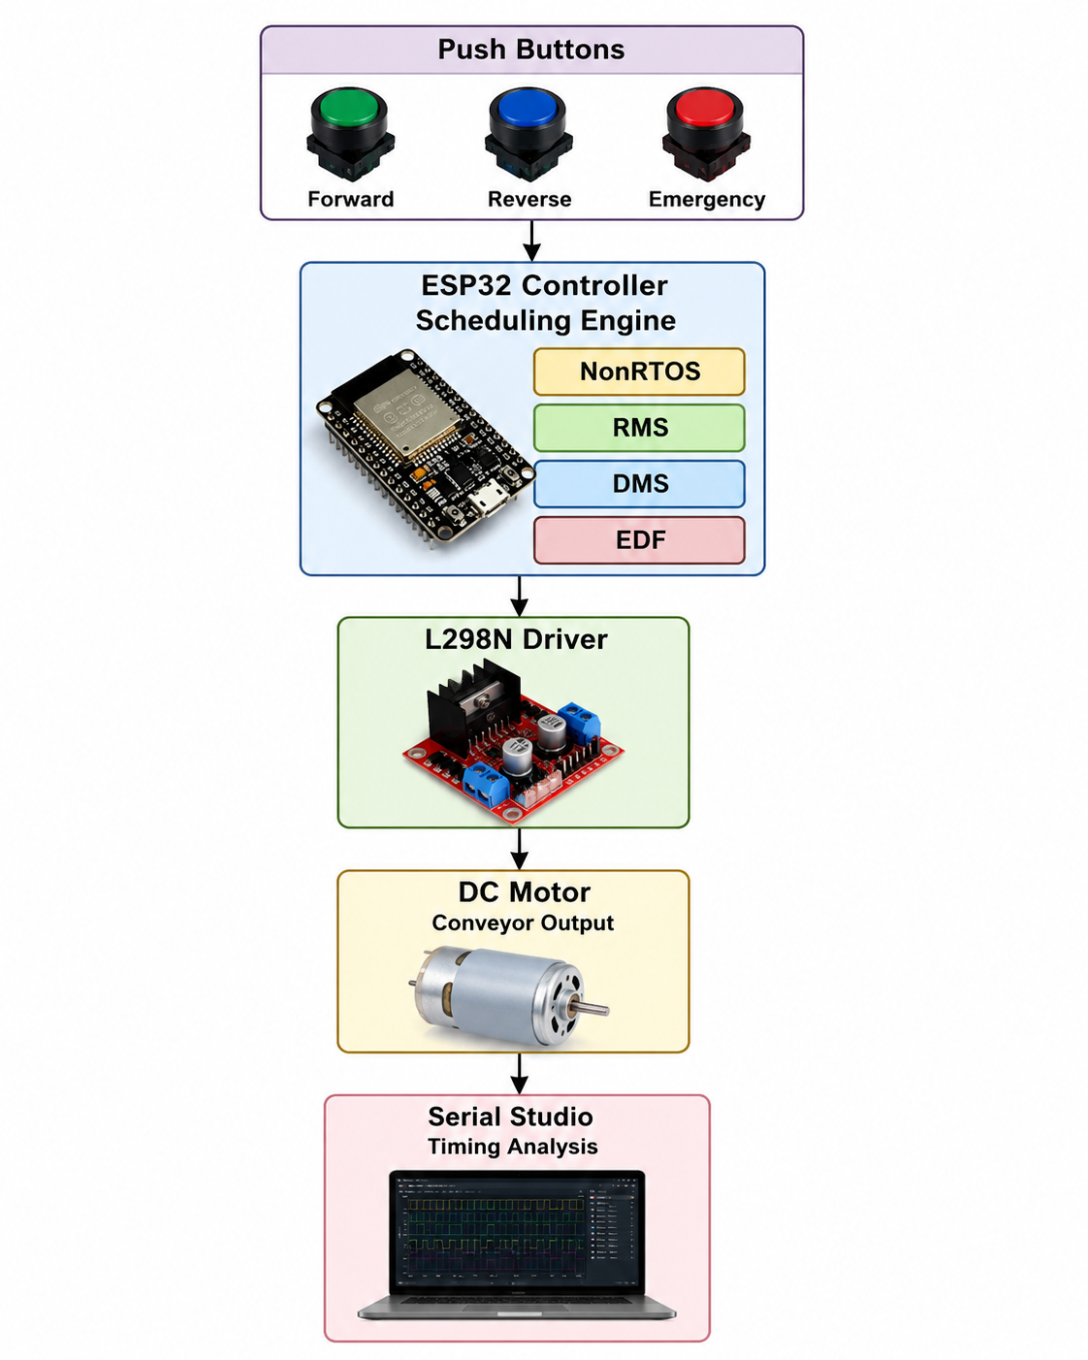

Fig 3.1 : Proposed System Block Diagram

The system receives task requests through push buttons representing Forward, Reverse, and Emergency operations. The ESP32 executes scheduling algorithms and controls motor behavior through the L298N motor driver. Timing information is transmitted to Serial Studio for execution analysis and visualization.

3.2 HARDWARE IMPLEMENTATION:

The hardware implementation of the proposed real-time scheduling system was developed using an ESP32 microcontroller, L298N motor driver, DC motor, and three push buttons to demonstrate and evaluate multiple scheduling techniques including Non-RTOS, Rate Monotonic Scheduling (RMS), Deadline Monotonic Scheduling (DMS), and Earliest Deadline First (EDF).
The hardware platform was designed to generate real-time task requests and execute motor control operations while measuring scheduling performance using execution time and response analysis.

A. ESP32 Microcontroller
The ESP32 acts as the central processing unit of the proposed system and performs all scheduling and control operations.
It executes the scheduling algorithms and manages multiple tasks simultaneously using FreeRTOS. The controller receives input commands from push buttons and generates corresponding output signals to drive the motor.
Functions performed by ESP32:
- Reads button inputs.
- Creates and schedules tasks.
- Executes NonRTOS, RMS, DMS, and EDF scheduling.
- Measures execution and response time.
- Sends timing values to Serial Studio.
- Controls motor operation.
Specifications:
Parameter | Value
Controller | ESP32 Dev Module
Operating Voltage | 3.3 V
Clock Frequency | 240 MHz
Wireless Support | WiFi + Bluetooth
GPIO Pins | Multiple

B. Push Button Module
Three push buttons were used to generate scheduling events and simulate real-time task requests.
Each button represents a different system operation.
Functions:
- Forward Button → Starts forward motor task.
- Reverse Button → Starts reverse motor task.
- Emergency Button → Immediately stops execution.
Button Configuration:
Button | GPIO
Forward | GPIO4
Reverse | GPIO5
Emergency | GPIO27
The buttons were configured using INPUT_PULLUP, where the input remains HIGH normally and becomes LOW when pressed.

C. L298N Motor Driver
The L298N motor driver was used as an interface between the ESP32 and DC motor because ESP32 GPIO pins cannot directly supply sufficient current to drive the motor.
The motor driver receives digital control signals from ESP32 and provides required current to rotate the motor.
Functions:
- Controls motor direction.
- Provides electrical isolation.
- Enables forward and reverse movement.
- Supports real-time motor switching.
Motor Driver Connections:
ESP32 | L298N
GPIO2 | IN1
GPIO15 | IN2
GND | GND
Working:
- IN1 HIGH + IN2 LOW → Forward
- IN1 LOW + IN2 HIGH → Reverse
- IN1 LOW + IN2 LOW → Stop

D. DC Motor
A DC motor was used as the output actuator to visualize scheduling decisions.
The motor rotates according to commands generated by different scheduling algorithms.
Motor Actions:
Operation | Motor State
Forward Task | Clockwise Rotation
Reverse Task | Anti-clockwise Rotation
Emergency Task | Immediate Stop
The motor operation was used to observe task execution behavior physically.

E. Serial Studio Interface
Serial Studio was used for timing visualization and performance analysis.
The ESP32 transmits execution parameters through serial communication, and Serial Studio converts them into graphs and timing plots.
Measured Parameters:
- Execution Time
- Response Time
- Latency
- Deadline
- Task Priority
Serial Studio helped compare scheduling performance among NonRTOS, RMS, DMS, and EDF implementations.

F. Hardware Working Procedure
The complete hardware operation follows the sequence below:
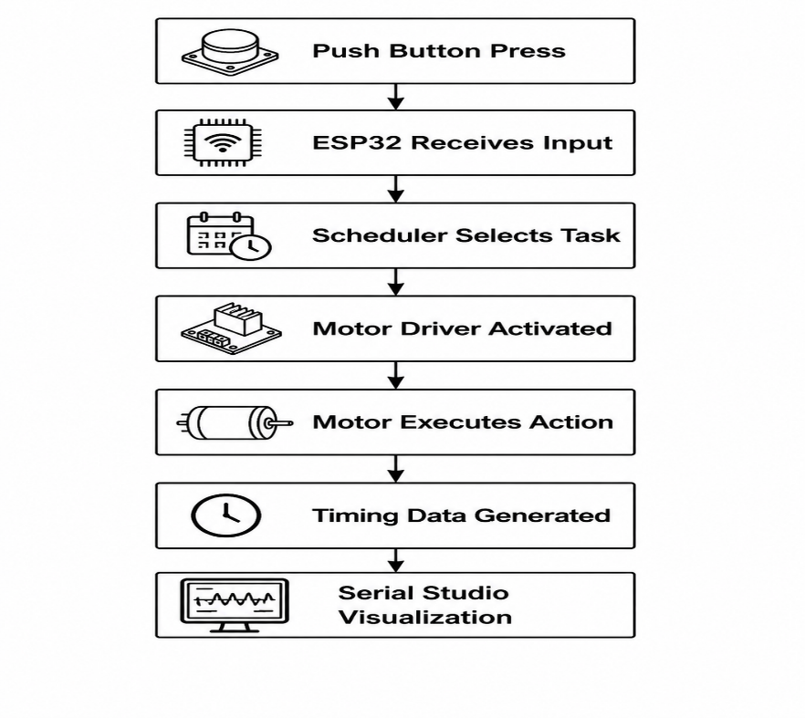
Fig 3.2 Hardware Implementation of Proposed RTOS Scheduling System

3.3 SOFTWARE IMPLEMENTATION:

The software implementation of the proposed real-time scheduling system was carried out using Arduino IDE, ESP32 development board, and the FreeRTOS library integrated within the ESP32 framework. The complete software was developed in Embedded C/C++ to implement and compare different task scheduling approaches for motor control applications.
The objective of the software implementation is to analyze the execution behavior of multiple scheduling algorithms and evaluate their impact on system timing performance. Four scheduling approaches were implemented and tested:
- Non-RTOS (Sequential Execution)
- Rate Monotonic Scheduling (RMS)
- Deadline Monotonic Scheduling (DMS)
- Earliest Deadline First (EDF)
The developed software continuously monitors the user inputs through push buttons and executes motor control operations according to the selected scheduling strategy. The generated timing parameters such as execution time, response time, and latency are transmitted through serial communication and visualized using Serial Studio for performance evaluation.
The software architecture is organized into multiple functional modules that collectively perform task creation, scheduling, motor control, timing computation, and visualization.

3.3.1 System Initialization
Initially, the ESP32 controller configures all required hardware peripherals including GPIO pins, serial communication, and FreeRTOS resources.
During initialization:
- Push buttons are configured as input devices using internal pull-up resistors.
- Motor driver pins are configured as output.
- Serial communication is initialized at 115200 baud rate.
- Required tasks are created and assigned execution priorities.
- Scheduler initialization is performed for RTOS-based execution.
After successful initialization, the system enters continuous execution mode and waits for user commands.

3.3.2 Input Handling Module
The input handling module continuously monitors three push buttons connected to the ESP32.
Forward Button
Triggers motor movement in forward direction.
Reverse Button
Triggers motor movement in reverse direction.
Emergency Button
Immediately interrupts current execution and stops motor operation.
Software debouncing is implemented using delay intervals to avoid false triggering and ensure reliable input detection.

3.3.3 Task Creation and Scheduling Module
The system operation is divided into independent tasks where each task performs a dedicated operation.
Input Task
Responsible for:
- Reading push button states
- Detecting command requests
- Generating task events
Control Task
Responsible for:
- Receiving scheduling decisions
- Driving the motor
- Executing directional control
Emergency Task
Responsible for:
- Immediate interruption
- Stopping motor operation
- Providing highest system responsiveness
Task scheduling behavior changes according to the selected scheduling algorithm.

3.3.4 Scheduling Algorithm Implementation
A. Non-RTOS Scheduling
In the Non-RTOS implementation, tasks execute sequentially inside the main loop without priority assignment.
Operation flow:
- Read input
- Execute motor command
- Wait for completion
- Process next request
This implementation produces larger response time because no task preemption exists.

B. Rate Monotonic Scheduling (RMS)
RMS assigns task priority based on periodic execution rates.
- Smaller period → Higher priority
- Larger period → Lower priority
Priority Assignment:
Task | Priority
Emergency Task | Highest
Input Task | Medium
Control Task | Lowest
Emergency events interrupt currently executing tasks.

C. Deadline Monotonic Scheduling (DMS)
DMS assigns priorities according to task deadlines.
- Short deadline → Higher priority
- Long deadline → Lower priority
Priority Assignment:
Task | Deadline
Emergency Task | 20 ms
Input Task | 100 ms
Control Task | 3000 ms
Tasks with tighter timing constraints execute first.

D. Earliest Deadline First (EDF)
EDF implements dynamic scheduling.
Priority changes during execution according to remaining deadlines.
Scheduling Rule:
Earliest Deadline → Highest Priority
This enables efficient CPU utilization and improved responsiveness during emergency execution.

3.3.5 Motor Control Module
Motor control is implemented using the L298N motor driver.
The ESP32 sends digital control signals through IN1 and IN2 pins.
Motor actions:
IN1 | IN2 | Motor Action
HIGH | LOW | Forward
LOW | HIGH | Reverse
LOW | LOW | Stop
The emergency task immediately disables both control outputs to stop motor operation.

3.3.6 Timing Measurement Module
The timing measurement module records system performance parameters.
Three timing metrics are evaluated:
Execution Time
Time required to complete task execution.
$$Execution Time=Stop Time-Start Time$$
Response Time
Total delay from task trigger until completion.
$$Response Time=Stop Time-Trigger Time$$

Latency
Delay between event occurrence and execution start.
$$Latency=Start Time-Trigger Time$$
Timing values are calculated using FreeRTOS timing APIs and Arduino timing functions.

3.3.7 Serial Communication and Visualization
The measured timing data is transmitted to the host computer through UART communication.
Serial Studio is used to:
- Display real-time task execution
- Plot timing graphs
- Compare scheduling algorithms
- Visualize response variation
Only required channels are enabled for visualization:
- Channel 4 → Execution Time
- Channel 7 → Task State / Scheduler Event
The collected data forms the basis for result analysis and scheduler comparison.

3.3.8 Software Tools Used
Tool | Purpose
Arduino IDE | Code Development
ESP32 Board Package | Hardware Support
FreeRTOS | Task Scheduling
Embedded C/C++ | Program Development
Serial Studio | Timing Visualization

3.4 FreeRTOS Architecture:

The proposed system is implemented using the FreeRTOS real-time operating system running on the ESP32 controller to achieve deterministic task execution and scheduling analysis. FreeRTOS enables concurrent execution of multiple tasks while efficiently utilizing processor resources through task prioritization and context switching mechanisms.

In this work, FreeRTOS is employed to implement and compare multiple scheduling algorithms including Rate Monotonic Scheduling (RMS), Deadline Monotonic Scheduling (DMS), and Earliest Deadline First (EDF). The scheduler manages task execution based on predefined priorities or deadlines and allows the system to respond quickly to critical events such as emergency motor stopping.

The FreeRTOS architecture consists of independent software tasks that communicate through shared variables and scheduler control.

3.4.1 FreeRTOS Functional Architecture:

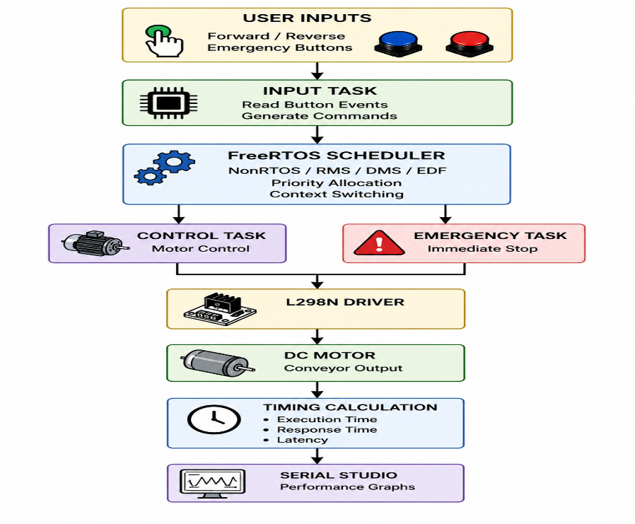
Fig: FreeRTOS Architecture of Proposed System
3.4.2 Task Organization
The system operation is divided into three independent FreeRTOS tasks.
1. Input Task
The Input Task continuously monitors push button events and detects user commands.
Functions:
- Read Forward button
- Read Reverse button
- Generate scheduler requests
- Trigger motor execution
Priority:
- Medium Priority (RMS/DMS)
- Dynamic Priority (EDF)

2. Control Task
The Control Task performs motor actuation according to scheduler decisions.
Functions:
- Execute motor movement
- Control L298N outputs
- Perform forward and reverse actions
- Measure execution timing
Priority:
- Low Priority
- Dynamic under EDF

3. Emergency Task
Emergency Task is responsible for system safety.
Functions:
- Interrupt running task
- Stop motor immediately
- Provide minimum response time
Priority:
- Highest Priority
- Deadline = 20 ms
3.4.3 Task Scheduling Mechanism
FreeRTOS executes tasks using scheduler policies.
NonRTOS
Sequential execution without task switching.
RMS
Static priority assignment based on task period.
DMS
Static priority assignment based on task deadline.
EDF
Dynamic priority assignment according to earliest deadline.
Scheduler operation:
- Task creation
- Ready state allocation
- Task execution
- Context switching
- Timing measurement
- Task completion

3.4.4 Task States in FreeRTOS
During execution, tasks move through different states.
State | Description
Ready | Waiting for CPU
Running | Currently executing
Blocked | Waiting for event
Suspended | Temporarily paused
Completed | Task finished
The scheduler continuously switches tasks between these states to maintain real-time execution.

3.4.5 Context Switching
Context switching allows the CPU to pause one task and execute another.
In this project:
- Emergency task preempts control task.
- RMS uses fixed priorities.
- DMS uses deadline-based switching.
- EDF performs dynamic switching.
This mechanism improves responsiveness and ensures timely execution.
3.4.6 Architecture Outcome
The implemented FreeRTOS architecture successfully enabled:
- Real-time motor scheduling
- Task prioritization
- Immediate emergency response
- Execution time measurement
- Response time comparison
- Serial Studio visualization
This architecture provided a platform to evaluate and compare multiple scheduling algorithms under identical hardware conditions.
Chapter-4 RESULT AND DISCUSSION

This section presents the experimental results obtained from the hardware implementation of the ESP32-based conveyor control system using FreeRTOS scheduling algorithms (RMS, DMS, and EDF). The performance evaluation was carried out using Serial Monitor and Serial Studio to measure execution time, response time, latency, scheduling behavior, emergency handling, and task priority changes.

4.1 Rate Monotonic Scheduling (RMS) Results
The RMS scheduler assigns priorities based on task period, where shorter periodic tasks receive higher priority. The experiment was performed using three tasks: Input Task, Forward/Reverse Motor Task, and Emergency Task.
Observed Results
From the Serial Monitor output:
Task | Execution Time (ms) | Response Time (ms) | Latency (ms) | Priority | Output
Input Task | 50 | 50 | 0 | High | Command Generated
Forward Task | 3000 | 3000 | 0 | Medium | Motor Forward
Reverse Task | 2800–3000 | 2800–3000 | 0 | Medium | Motor Reverse
Emergency Task | 20 | 20 | 0 | Highest | Motor Stopped
Discussion
The RMS implementation demonstrated predictable execution behavior and maintained deterministic scheduling throughout the experiment. The input task received higher priority and executed immediately after button activation. The emergency task achieved the shortest execution time (20 ms) and preempted currently executing motor tasks to stop the conveyor instantly.
The motor control task required longer execution time (approximately 3000 ms) because of sustained conveyor operation. However, RMS successfully ensured that critical emergency actions were never delayed.
Observation:
- Zero scheduling latency achieved
- Emergency task interruption worked successfully
- Stable motor control execution observed
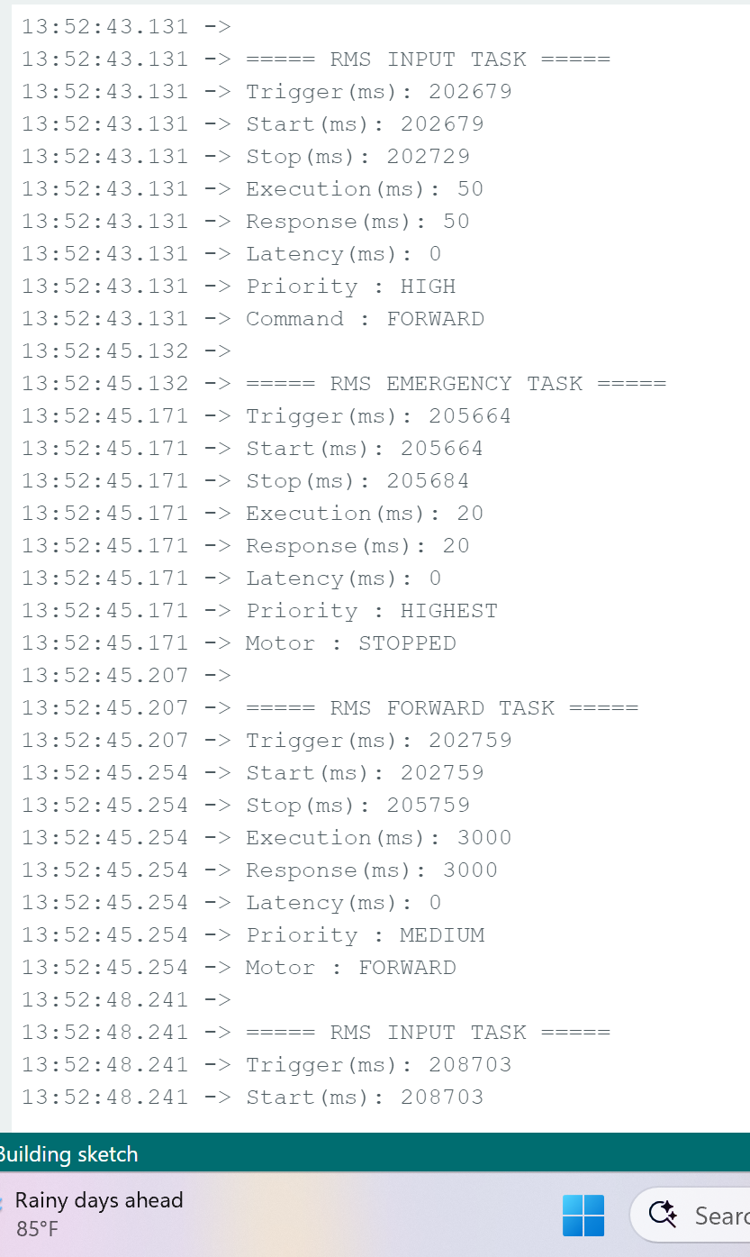
Fig. 4.1. RMS Scheduling Execution Results from Serial Monitor

4.2 Deadline Monotonic Scheduling (DMS) Results
DMS scheduling allocates priority according to relative deadlines rather than task periods.
Observed Results
Task | Execution Time (ms) | Response Time (ms) | Deadline (ms) | Priority
Input Task | 40 | 40 | 100 | Medium
Control Task | 2500 | 2500 | 3000 | Low
Emergency Task | 10 | 10 | 20 | Highest
Discussion
The DMS scheduler showed improved responsiveness compared with RMS. Since the emergency task had the smallest deadline (20 ms), it received maximum scheduling priority and interrupted motor execution immediately.
Input processing time reduced to 40 ms, indicating better response capability for real-time control actions.
Compared with RMS:
- Faster emergency response
- Lower input execution time
- Better deadline satisfaction
Observation:
DMS improved responsiveness while preserving deterministic scheduling.

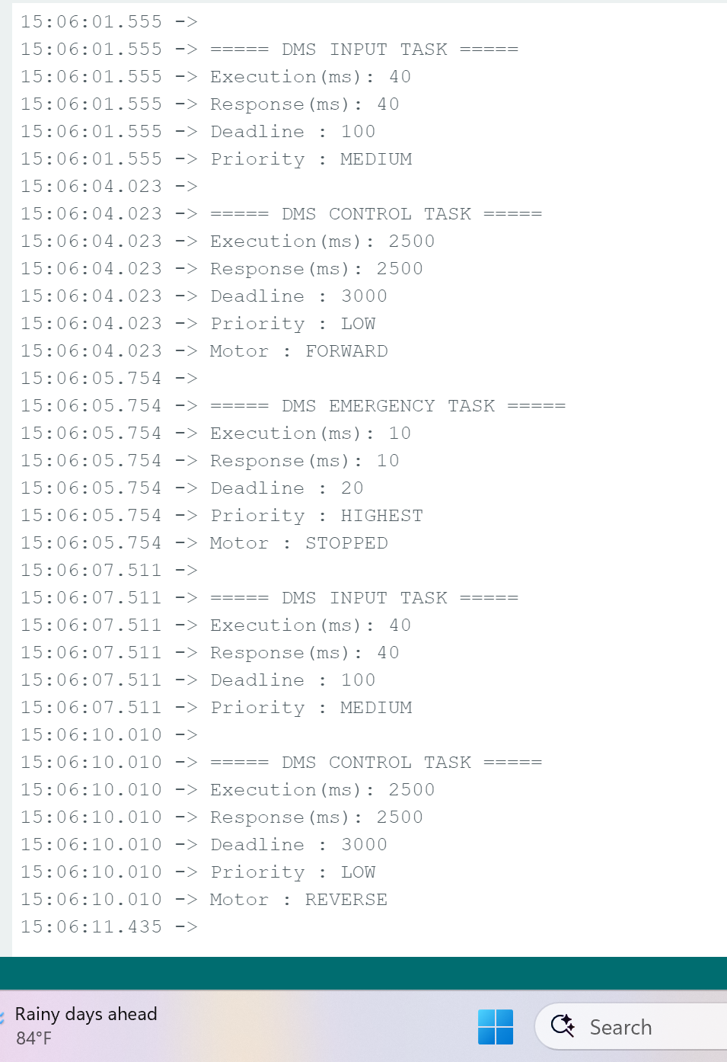
Fig. 4.2. DMS Scheduling Performance Analysis

4.3 Earliest Deadline First (EDF) Results
EDF scheduling dynamically changes task priority based on the nearest execution deadline.
Observed Results
Task | Execution Time (ms) | Response Time (ms) | Deadline (ms)
Input Task | 30 | 30 | 100
Reverse Task | 2000 | 2000 | 3000
Emergency Task | 5 | 5 | 20
Discussion
EDF demonstrated the best scheduling efficiency among all tested algorithms. Dynamic priority allocation allowed immediate execution of urgent tasks.
Emergency operation completed in only 5 ms, producing the fastest reaction among all schedulers.
EDF also reduced overall motor control completion time compared with RMS and DMS.
Observation:
- Lowest response time achieved
- Dynamic priority adaptation successful
- Highest real-time efficiency observed
- 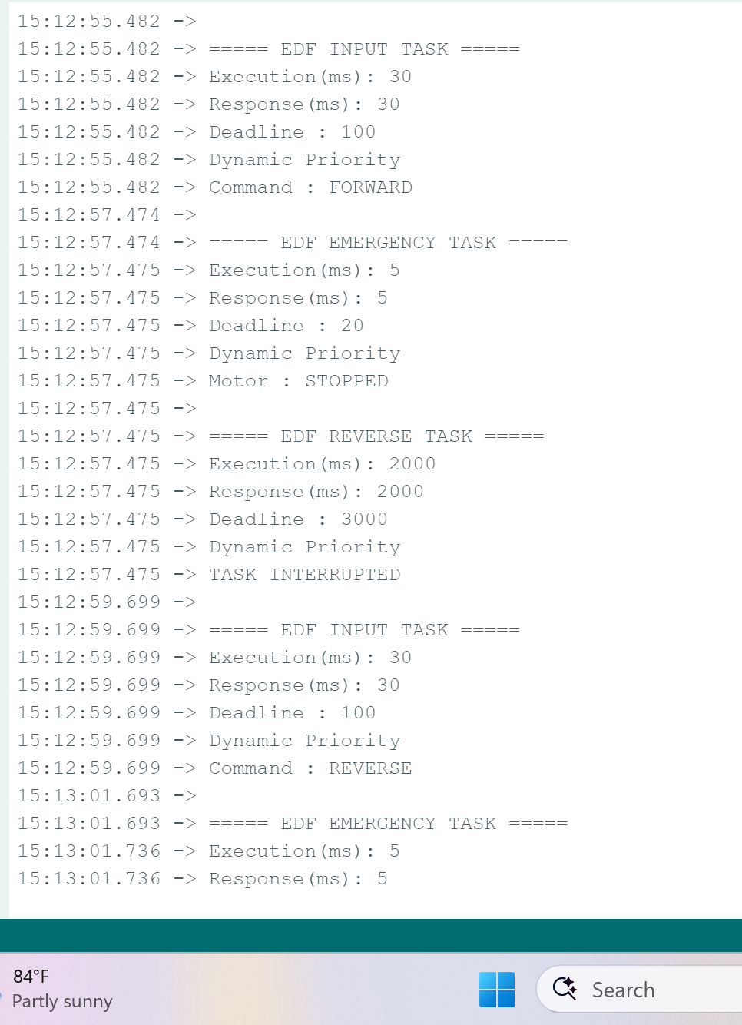
Fig. 4.3. EDF Scheduling Results and Task Execution

4.4 Serial Studio Performance Visualization
Serial Studio was used to visualize runtime scheduling parameters and validate timing performance.
Measured parameters:
- Trigger Time
- Start Time
- Stop Time
- Execution Time
- Response Time
- Latency
- Scheduler State
Discussion
The generated graphs confirmed correct task scheduling behavior.
From the plots:
- Execution and response values remained stable.
- Emergency tasks created sharp transitions indicating immediate task switching.
- RMS produced larger execution peaks.
- DMS reduced delay.
- EDF showed the shortest response profile.
Fig. 4.4. Real-Time Task Visualization using Serial Studio

5.5 Comparative Performance Analysis
Parameter | RMS | DMS | EDF
Input Execution (ms) | 50 | 40 | 30
Emergency Execution (ms) | 20 | 10 | 5
Motor Execution (ms) | 3000 | 2500 | 2000
Response Time | Moderate | Fast | Fastest
Scheduling Type | Fixed Priority | Deadline Priority | Dynamic Priority
Discussion
Among all scheduling techniques, EDF achieved the best overall performance, followed by DMS, while RMS provided stable deterministic execution suitable for periodic industrial tasks.
Final performance ranking:
EDF > DMS > RMS

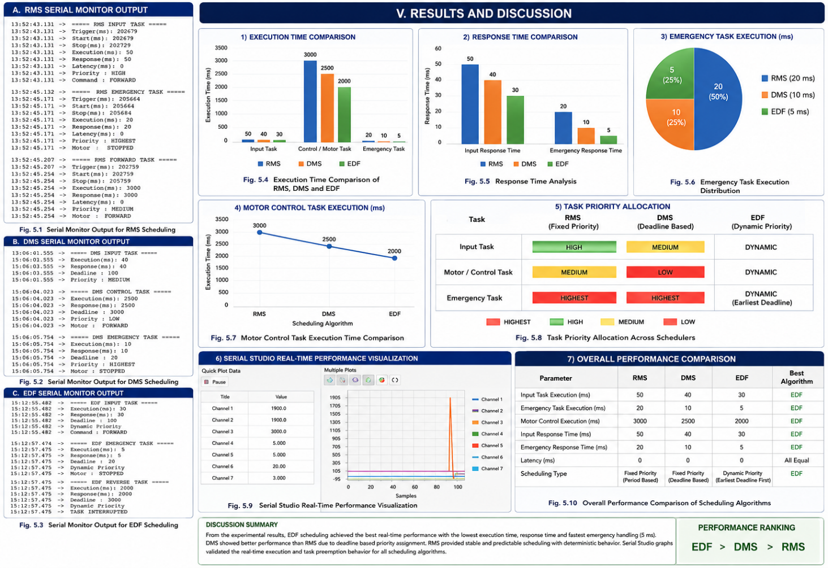

CHAPTER-5: CONCLUSION

This project presented the design and implementation of a real-time conveyor control system using ESP32 and FreeRTOS scheduling algorithms for task execution and performance evaluation. The developed system successfully integrated push-button inputs, motor control using L298N driver, FreeRTOS task scheduling, and real-time monitoring through Serial Studio to demonstrate practical RTOS concepts.
Three scheduling algorithms, namely Rate Monotonic Scheduling (RMS), Deadline Monotonic Scheduling (DMS), and Earliest Deadline First (EDF), were implemented and experimentally evaluated based on execution time, response time, latency, priority assignment, and emergency handling performance.
From the experimental observations:
- RMS provided stable and deterministic execution using fixed-priority scheduling and achieved reliable periodic task execution.
- DMS improved deadline satisfaction and reduced response delay by assigning priorities according to deadlines.
- EDF demonstrated the best overall scheduling performance through dynamic priority allocation and achieved the minimum execution and response times.
The obtained results showed that:
- RMS emergency response = 20 ms
- DMS emergency response = 10 ms
- EDF emergency response = 5 ms
- Scheduling latency remained approximately 0 ms, validating efficient real-time execution.
Serial Studio visualization further confirmed successful task execution, emergency preemption, and real-time behavior of the implemented scheduling methods.
Therefore, it can be concluded that EDF achieved the highest performance among the implemented scheduling algorithms, while RMS and DMS also provided stable and efficient execution for industrial control applications. The proposed implementation successfully demonstrated the practical application of RTOS scheduling concepts in embedded systems and validated the effectiveness of ESP32-based real-time task management.

Future Scope
- Integration of IoT-based remote monitoring
- Implementation of multi-motor conveyor control
- Addition of sensor-based automation
- Testing using advanced scheduling techniques and industrial workloads
- Real-time cloud logging and analytics for predictive monitoring

REFERENCES:

[1] Zhang, Yuanyuan, and Junnan Li. "Design of real-time embedded system based on STM32 and free RTOS with optimization of advanced task scheduling algorithm." In 2025 3rd Cognitive Models and Artificial Intelligence Conference (AICCONF), pp. 1-5. IEEE, 2025.

[2] Benmachiche, Abdelmadjid, Khadija Rais, and Hamda Slimi. "Adaptive Real-Time Scheduling Algorithms for Embedded Systems." arXiv preprint arXiv:2512.21364 (2025).

[3] Kwon, Gahyeon, Yeongeun Shim, Kyungwoon Cho, and Hyokyung Bahn. "Real-Time task scheduling and resource planning for IIoT-based flexible manufacturing with human–machine interaction." Mathematics 13, no. 11 (2025): 1842.

[4] Gharbi, Ibrahim, Hamza Gharsellaoui, and Sadok Bouamama. "Energy-Aware Real-Time Scheduling of Sporadic Tasks Using a Hybrid Genetic Algorithm with EDF and DVFS." Engineering, Technology & Applied Science Research 15, no. 5 (2025): 28144-28149.

[5] Reddy, B. Naresh Kumar, Y. Charan Krishna, P. Naga Satya Nitish, and Sita Devi Bharatula. "Optimizing task scheduling in multi-thread real-time systems using augmented particle swarm optimization." In 2024 37th International Conference on VLSI Design and 2024 23rd International Conference on Embedded Systems (VLSID), pp. 666-671. IEEE, 2024.

[6] Zhao, Tianming, Wei Li, and Albert Y. Zomaya. "Real-time scheduling with predictions." In 2022 IEEE Real-Time Systems Symposium (RTSS), pp. 331-343. IEEE, 2022.

[7] Moyano, Victor Gabriel, Zain Alabedin Haj Hammadeh, Selma Saidi, and Daniel Lüdtke. "Global scheduling of weakly-hard real-time tasks using job-level priority classes." ACM Transactions on Embedded Computing Systems 25, no. 2 (2026): 1-28.

[8] Luo, Feng, Yunpeng Li, Zitong Wang, Yi Ren, Yingpeng Tong, Zhouping Zhang, and Qin Liu. "A time-triggered communication method based on urgency-based scheduler in time-sensitive networking." arXiv preprint arXiv:2412.20077 (2024).

[9] Chen, Ge, Junbo Zhang, Mingchao Ning, Wei Cui, and Mengcheng Ma. "Task scheduling in real-time industrial scenarios." Computers & Industrial Engineering 182 (2023): 109372.

[10] Gurupriya, M., P. Lahari, S. Sumanjali, and R. Manjunath. "Comparative Analysis of Scheduling Algorithms in Real Time Systems." In 2025 8th International Conference on Computing Methodologies and Communication (ICCMC), pp. 201-205. IEEE, 2025.

[11] Gurupriya, M., P. Lahari, S. Sumanjali, and R. Manjunath. "Comparative Analysis of Scheduling Algorithms in Real Time Systems." In 2025 8th International Conference on Computing Methodologies and Communication (ICCMC), pp. 201-205. IEEE, 2025.

[12] Niranjan, M., and P. Sivraj. "Message Latency Analysis in the Controller Area Network." In 2025 Innovations in Power and Advanced Computing Technologies (i-PACT), pp. 1-7. IEEE, 2025.

[13] Chandru, R., P. Gopi, and B. Akash. "IoT-Enabled Manufacturing System with Freertos Using CAN Protocol for Predictive Maintenance." In 2025 6th International Conference on Inventive Research in Computing Applications (ICIRCA), pp. 576-582. IEEE, 2025.

[14] Wavale, Aditya Bhushan, and Surekha Paneerselvam. "Comparative Study of Bare Metal and FreeRTOS Implementations for Real-Time Sensor-Actuator Systems." In 2025 5th Asian Conference on Innovation in Technology (ASIANCON), pp. 1-7. IEEE, 2025.

[15] Yashaswini, B., and Surekha Paneerselvam. "Real-Time Airbag Deployment System Using FreeRTOS with Runtime Metrics." In 2025 5th Asian Conference on Innovation in Technology (ASIANCON), pp. 1-7. IEEE, 2025.

[16] Ramegowda, Deepak, and Man Lin. "Energy efficient mixed task handling on real-time embedded systems using FreeRTOS." Journal of Systems Architecture 131 (2022): 102708.

[17] Zhou, Junyan. "Real-time task scheduling and network device security for complex embedded systems based on deep learning networks." Microprocessors and Microsystems 79 (2020): 103282.

[18] Büyükçolak, Ömer Serhat, and Ramazan Yeniçeri. "Quadrotor model implementation on raspberry pi zero and pi 4 boards using freertos." In 2023 12th Mediterranean Conference on Embedded Computing (MECO), pp. 1-4. IEEE, 2023.

